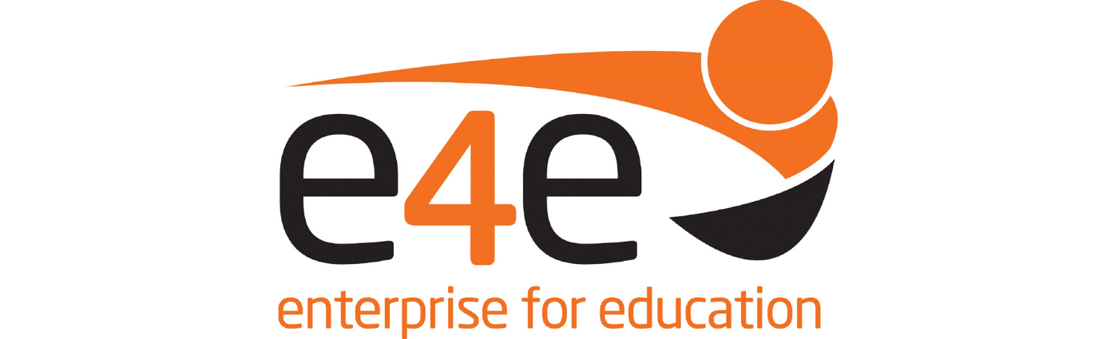

E4E Derby City Raising Aspirations Awards 2021

AWARDS SUMMARIES 125694NCF25/06/201900000006

The Derby City Raising Aspirations Awards 2021 aim to celebrate local student success, give recognition to their achievements and highlight the amazing schools, employers and individuals who go above and beyond to support young people to achieve their true potential.

Employer contact at school is vital for students’ personal and academic growth, career choice and future achievement. Local employers and local schools share a common goal to connect and develop all our young people so that they are best positioned for the world of work.
.
These awards are open to all Derby City students in school years 7-13. E4E celebrates all our young people regardless of their background or starting point. We believe in the power and rights of young people to determine their own future and believe it is our shared responsibility to support them along that journey. We recognise that achievement comes in many different forms unique to each individual and we celebrate them all.

The 2021 Awards event will be held in October 2021 and will be attended (live or online) by student award finalists, parents, school leaders and business representatives. Once again, E4E are proud to celebrate local achievement with all our stakeholders.

We believe that the combined passion and determination of local young people, schools and our business community is core to the future success of this great city. Our 9 award categories are designed to celebrate them all.

If you would be interested in sponsoring one of our E4E Raising Aspirations Awards this year, please get in touch via this online form or call Arshad Iqbal on 07812 130527.

E4E School of the Year Open for Sponsorship

This award is in recognition of secondary schools that have generated significant impact for their students, in preparing their young people for the world of work and raising aspirations. Their practice in embedding one or more of the Gatsby Benchmarks to support students achieve their potential is key.

In particular judges would like to see innovative and impactful encounters with employers/FE/HE/other post 16 options, and examples of how schools are linking curriculum to the world-of-work and careers aspirations. This is not limited to services provided by E4E employer volunteers.

E4E Volunteer of the Year Open for Sponsorship

This award is to recognise and celebrate the support of our amazing local employer community. Through a wide range of E4E activities and support to schools these volunteers help raise aspirations, inform young people about the actual realities and needs of the workplace, and inspire them to achieve more. Although all E4E employer volunteers help to make a difference to the lives of young people, the judging panel can only select a handful of stand-out volunteers each year.

What makes these employers/volunteers so invaluable are their qualities of positivity and enthusiasm to support young people, their abilities to engage young people in careers activities, and their contribution to young peoples’ development this year.

Young Achiever Sponsored by Rolls-Royce plc TBC

Terms of Reference

This award is for young people who through participation in an E4E activity or similar employer engagement have been inspired, informed and/or nudged to achieve more than they might otherwise have done. These activities will have helped students develop leadership skills +/or increased their confidence, developed their speaking skills +/or their self-awareness allowing them to make realistic choices about their future.
The judges will be looking for young people who have come from a low starting point due to family situation, academic struggles or socio-economic background and who have shown personal drive to become the best version of themselves. Achievement might include overcoming adversity & obstacles faced or progression in the curriculum, citizenship and/or community work. They could be role models for other people in their class/ school/ community and will have had positive experiences of the world of work.

D2N2 Employability Goals: Informed; Experience; Achieving
Skillsbuilder: Leadership; Speaking.

Aiming High Open for Sponsorship

Terms of Reference

This award is for students with the best laid plans for future success in the workplace. It is targeted at young people with high aspirations to achieve in their chosen career. Whilst academic based aspirations are certainly not precluded, the judges will be looking for evidence of high aspirations in their chosen field including self-motivation through extra-curricular activities to support these aspirations, as well as the steps being taken in school to fulfil those high aspirations. Candidates will need to show diligence in their studies at school and self-assurance in communicating.
The judges will be looking for evidence of the steps this young person has taken to create the best pathway to success in their chosen career and have the skills to present themselves to a future employer.

D2N2 Employability Goals: Self-assured; Self-motivated; Aspirational.
Skillsbuilder: Aiming High; Speaking; Listening.

Brilliance Award Open for Sponsorship

Terms of Reference

Eligibility for this award is ringfenced to students registered as SEN in any mainstream school, special school, PRU or virtual school and alternative provision units within a mainstream school.

This award is for a young person who is outstandingly brilliant, for reasons that may not be obvious to all. Judges will be looking for evidence to back why you class them as “brilliant”, including overcoming adversity, staying positive, starting over again, or sheer determination in one area or many. Candidates may have made exemplary changes to their engagement in school education or extra-curricular activities and being more accountable for their learning.

D2N2 Employability Goals: any one or more of the following - Self-assured; Self motivated; Aspirational; Informed; Experience; Achieving; Accountable; Resilient; Entrepreneurial; Co-operative.
Skillsbuilder: any one or more of the following - Listening; Speaking; Problem Solving; Creativity; Staying Positive; Aiming High; Leadership; Teamwork.

STEM Award Open for Sponsorship

Terms of Reference

This award is for a young people person who has shown a passion for and achievement in any STEM subject(s) – Science, Technology, Engineering and Mathematics
We welcome applications for students that who have achievements in academic progression, practical application, independent learning and a general enthusiasm for the subject/s.
Judges will be looking for students who are aiming high within STEM subject/s, who are able to explore solutions for to problems and who are able to develop ideas creatively.

D2N2 Employability Goals: Aspirational; Achieving; Accountable
Skillsbuilder Skills: Problem Solving; Creativity; Aiming High

Creativity Award Open for Sponsorship

Terms of Reference

This award is for students who have shown a passion for and flair in any creative subject/s (art, design, music, drama, etc) and/or those that that apply creativity beyond these subject areas.
We welcome applications for students who have achievements in academic progression, practical application, independent learning and/or enthusiasm for the subject/s.
Alternatively, candidates could be those who have applied creativity or creative problem solving in other school subjects (e.g. Maths, English, Science) +/or extra-curricular activities (e.g. innovative developments/delivery of ideas, products or service to others).

D2N2 Employability Goals: Entrepreneurial; Co-operative.
Skillsbuilder Skills: Problem Solving; Creativity.

Resilience Award Open for Sponsorship

Terms of reference

This award goes to young people who have shown resilience in their academic studies, careers-related learning and/or extra-curricular activities despite the recent demands of blended learning, at home and in school.
They have shown diligence in their work, stayed positive and/or sought help to ensure they engage and achieve their highest possible outcomes.
Judges will also be looking for students who can learn from their past experience. Young people who have worked hard and been accountable for their actions or those who looked for opportunities in difficult situations.

D2N2 Employability Goals: Accountable; Resilient.
Skillsbuilder Skills: Staying Positive

Derby School Debating Competition Open for Sponsorship

E4E proudly work alongside the Derby and District Law Society and The University of Derby Law School to provide this unique opportunity to local students.

Each year, small teams of young people from Derby City schools develop, harness and sharpen their debating and communication skills with the support of expert local law firms and University of Derby Law School students.

This award is for the winner and finalists of the Derby Schools Debating Competition 2021.

